When the customer is selected in the Suitelet and the required item fulfillments are selected.

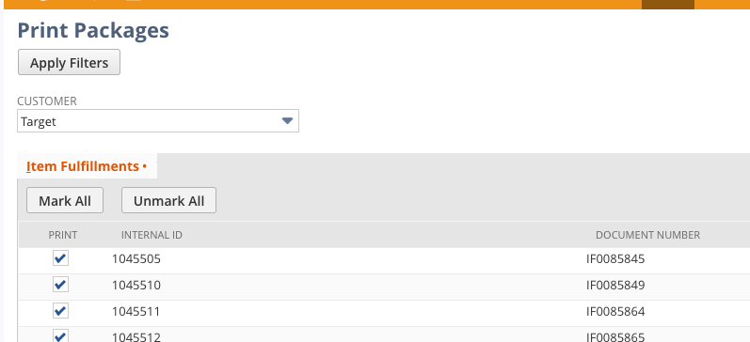

There needs to be a ‘submit’ or ‘print labels’ button on the form.

When the Print Labels button is clicked, all selected item fulfillments should have a custom Package record created in this custom record:

https://5637369.app.netsuite.com/app/common/custom/custrecordentrylist.nl?rectype=590



The logic should be as follows for each item fulfillment and these are the fields to be populated :

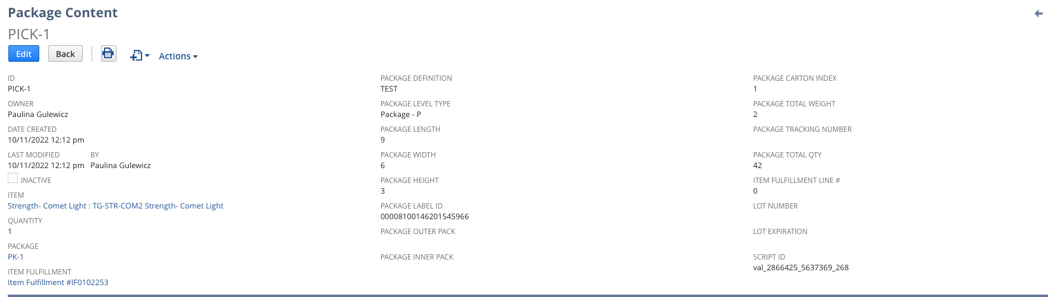

* ID: Each record created will have a unique ‘Pick ID’ value and will be sequential from the previous ID value. 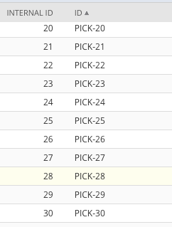
* Owner: This will be the name of the individual that generated the package record (the person that clicked ‘Print Labels’ from the suitelet)
* Date Created: The date the record was created.
* Last Modified: The date the record was created.
* Item: The item from the line item on that fulfillment.
* Qty: The qty for that line item on the fulfillment.
* Package: Each fulfillment will get a unique package ID created. This package ID will be referenced for all line items on that item fulfillment. Here is a link to where those package ID’s are stored (see below for more details): <https://5637369.app.netsuite.com/app/common/custom/custrecordentrylist.nl?rectype=584>
* Item Fulfillment: This will be a link to the item fulfillment record this line was created from.
* Package Definition: This will ALWAYS be Target Package 12x9x5.5.
* Package Level Type: This will always be populated with Package - P.
* Package Length: This is pulled from the Length field on the Target Package (<https://5637369.app.netsuite.com/app/common/custom/custrecordentry.nl?rectype=583&id=2>)
* Package Width: This is pulled from the Width field on the Target Package.
* Package Height: This is pulled from the Height field on the Target Package.
* Package Carton Index: This is always populated with a value of 1.
* Weight: This is pulled from the Weight field on the Target Package.
* Package Total Qty: This is the total qty for all items on the item fulfillment. Not the total lines, but the sum of all qty’s on all the lines.
* Item Fulfillment Line: This is the line number for this item on the item fulfillment.
* Script ID: This appears to be auto populated by NetSuite.

Package List: The following fields are part of the Package List record creation:

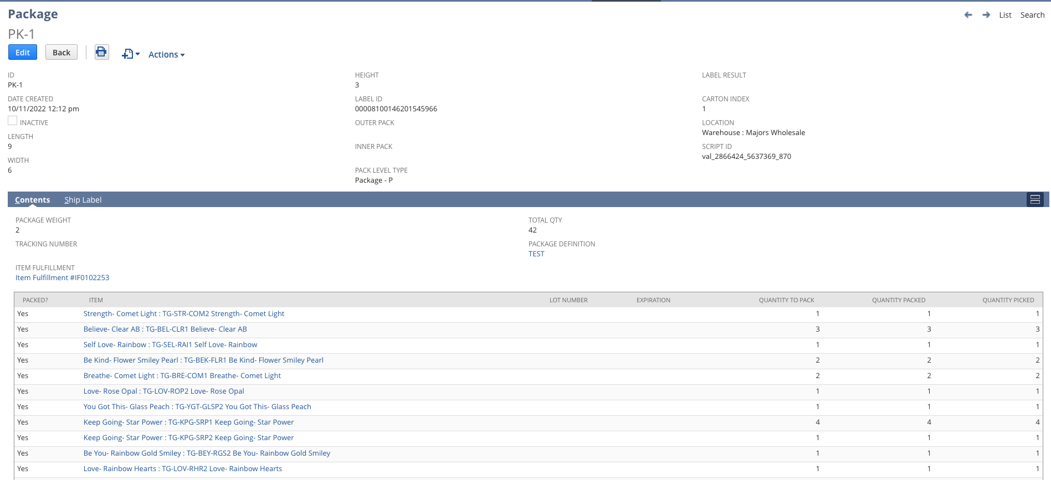

* Package ID: This is the unique package ID referenced above. Each item fulfillment will have a unique package ID.
* Date Created: The date the record was created.
* Package Length: This is pulled from the Length field on the Target Package (<https://5637369.app.netsuite.com/app/common/custom/custrecordentry.nl?rectype=583&id=2>)
* Package Width: This is pulled from the Width field on the Target Package.
* Package Height: This is pulled from the Height field on the Target Package.
* Label ID: This is created once the label is generated.
* Pack Level Type: This is always populated with Package - P.
* Carton Index: This is always populated with a value of 1.
* Location: This is the location value from the item fulfillment.
* Script ID: This seems to be auto populated by NetSuite.
* Package Weight: This is pulled from the Weight field on the Target Package.
* Item Fulfillment: This is the item fulfillment this record was created from.
* Total Qty: This is the total qty for all items on the item fulfillment. Not the total lines, but the sum of all qty’s on all the lines.
* Package Definition: This will ALWAYS be Target Package 12x9x5.5.
* Contents Section:
  + This will list all items from that item fulfillment including:
    - Packed = Yes
    - Item
    - Qty to Pack = Qty from the line
    - Qty Packed = Qty from the line
    - Qty Picked = Qty from the line